“Care Transition Efficiency & Placement Outcome Analytics”

Abstract

Agencies like the U.S. Department of Health and Human Services and U.S. Customs and Border Protection must effectively coordinate the various stages of managing children in the care transition system, including apprehension, custody, transfer, and discharge. Delays, backlogs, and uneven placement results might result from inefficiencies in this system.
In order to assess system performance utilizing important indicators like transfer efficiency, discharge efficacy, pipeline throughput, and backlog buildup rate, this study offers a data-driven analysis of the care pipeline. Python-based tools are used to process and analyze the dataset, making it possible to identify system trends, bottlenecks, and temporal patterns.
Streamlit is used to create an interactive dashboard that shows how children progress through various phases, offering real-time information and aiding in decision-making. The findings underscore the need for better coordination and monitoring systems by highlighting areas of inefficiency and variability.
The suggested analytical method can help stakeholders and policymakers optimize the care transfer process by improving transparency and offering a scalable framework for performance evaluation.

Introduction

There are several steps involved in managing children who enter the care system, including as apprehension, custody, transfer, and final placement. These phases make up an organized care pipeline and are mostly managed by organizations like the U.S. Department of Health and Human Services and U.S. Customs and Border Protection.
To guarantee prompt treatment, safety, and the successful reunification of children with appropriate sponsors, effective coordination between these phases is essential. However, delays, inefficiencies, and backlog accumulation are frequently caused by this pipeline's complexity, which can have a detrimental effect on overall results.
Analytical techniques can be used to assess such systems' performance as data becomes more readily available. It is feasible to assess key performance indicators, locate bottlenecks, and comprehend temporal patterns within the care process by utilizing data analytic tools.
In order to evaluate effectiveness, throughput, and result stability, this study focuses on data-driven analysis of the care transition pipeline. The goal is to use metrics-based evaluation and visualization to deliver actionable insights.
Additionally, to facilitate real-time monitoring and improved decision-making, an interactive dashboard is created using contemporary data visualization tools. This strategy increases openness and helps stakeholders raise the system's overall efficacy.

INDEX

- Project Overview ----------------------------------------------------------------------------- 1
1.1 Project title 1
1.2 objective 1
1.3 Stakeholder 1
2. Data Description ----------------------------------------------------------------------------- 2
2.1 Dataset columns 2
2.2 Data Preparation 2
3. Methodology ---------------------------------------------------------------------------- 3
3.1 Tools and Technologies 3
3.2 Analytical Approach 3
4. Architecture --------------------------------------------------------------------------- 4 & 6
4.1 Dashboard Module 4
4.2 Key Performance Indicators (KPIs) 4
4.3 Filters 5
4.4 Color & Design 5
5. Visualization \ Dashboard --------------------------------------------------------------- 7 & 10
5.1 Visualization 7
5.2 Insights 10
6. Future Work --------------------------------------------------------------------------- 11
6.1 Future Work 11
7. Conclusion --------------------------------------------------------------------------- 12
7.1 Conclusion 12
7.2 Reference 12

Chapter 1: Project Overview

  - Project title
“Care Transition Efficiency & Placement Outcome Analytics”

  - objective
• To analyze the care transition pipeline of children using data-driven techniques.
• To evaluate system performance through key metrics such as transfer efficiency, discharge
effectiveness, pipeline throughput, and backlog rate.
• To identify bottlenecks and inefficiencies in different stages of the care process.
• To develop an interactive dashboard for visualization and real-time monitoring.
• To provide actionable insights for improving decision-making and overall care outcomes.

  - Stakeholder
The U.S. Department of Health and Human Services and U.S. Customs and Border Protection, two significant federal organizations in charge of overseeing various phases of the care transition pipeline, are among the project's principal stakeholders. These agencies play a critical role in handling the intake, custody, transfer, and discharge processes of children within the system. Their efficiency and coordination have a direct impact on the care process's overall efficacy and performance.
Apart from the aforementioned key agencies, policymakers are significant stakeholders who utilize the insights derived from this analysis to create and execute policies that are intended to enhance system efficiency and guarantee improved care outcomes. Administrative authorities and program managers are also important stakeholders because they oversee day-to-day operations, assign resources, and resolve system bottlenecks.
By using the dashboard to analyze trends, assess key performance indicators, and pinpoint areas in need of improvement, data analysts and operational teams further contribute as stakeholders. They play a crucial part in turning unprocessed data into useful insights that facilitate well-informed decision-making. A more effective pipeline guarantees prompt care, a smaller backlog, and improved results for kids.
All things considered, this project offers a clear, interactive, and data-driven picture of the system, which benefits all stakeholders. It improves openness, permits ongoing observation, and makes strategic decision-making easier, all of which help to improve the care transfer process as a whole.
Chapter 2: Data Description
2.1 Dataset columns
This study's dataset includes data about children's care transition pipeline at various phases. The mobility and status of children within the system are captured by its six main columns.
The columns include CBP Intake, which shows the number of children entering the system while in the care of U.S. Customs and Border Protection, and Date, which shows the chronology of documented observations. The number of minors detained at the first stage is reflected in CBP Custody.
Furthermore, HHS Custody denotes children under HHS supervision, whereas CBP to HHS signifies the number of children transferred to the U.S. Department of Health and Human Services. Lastly, the number of children who are successfully released or reunited with their sponsors is recorded by HHS Discharged.
This dataset enables the analysis of system flow, efficiency and performance across different stages of the care pipeline.

2.2 Data Preparation
To guarantee correctness, consistency, and suitability for analysis, the dataset underwent a number of preprocessing procedures. To preserve consistency and clarity, the column names were first changed to make them simpler to understand and utilize in subsequent calculations
To allow for time-based analysis, the Date field was transformed into a datetime format. In order to ease temporal pattern analysis and aggregation at various levels, the date was further broken down into distinct Month and Day components
To prevent mistakes during analysis, missing values and discrepancies in the dataset were examined and dealt with properly. To guarantee accurate computations and visualizations, the data types of each column were checked and adjusted as needed. To ensure data reliability, outliers and incorrect values were also investigated. In order to prepare the data for calculating key performance indicators and producing visual insights, the appropriate transformations were also applied.
The dataset was cleaned, organized, and prepared for effective analysis and dashboard creation thanks to these pre-treatment procedures

Chapter 3: Methodology

3.1 Tools and Technologies
Python: Used for key performance indicator computation, data processing, and analysis.
Pandas: Used for dataset transformation, cleansing, and data manipulation.
NumPy: Used for handling invalid or missing values and performing numerical computations.
Matplotlib: This tool is used to create visualizations including trend analysis, bar charts, and line charts.
Seaborn: Used to create improved and aesthetically pleasing statistical charts.
Plotly: used to create dynamic, interactive visualizations including complex graphical representations and doughnut charts.
Streamlit: Used to create an interactive web-based dashboard for analysis and visualization in real time
3.2 Analytical Approach
This study's analytical strategy is based on an extensive data-driven methodology designed to assess the effectiveness and performance of the care transition pipeline. In order to provide a clear knowledge of how children progress through several stages overseen by organizations like the U.S. Department of Health and Human Services and U.S. Customs and Border Protection, the research mainly uses descriptive analytics to summarize and explain the dataset.
Additionaly, time-series analysis is used to look at patterns and changes across time. The study finds temporal patterns, seasonal variations, and times of high or low system activity by examining data at daily and monthly intervals.
The calculation of performance metrics, or key performance indicators (KPIs), such as transfer efficiency, discharge effectiveness, pipeline throughput, and backlog build up rate. These indicators are intended to quantitatively evaluate system performance, draw attention to inefficiencies, and pinpoint crucial process bottlenecks. The study offers insights into how well kids are moved, handled, and released from the system by assessing these metrics.
Since they convert complicated numerical data into understandable graphical representations, visualization techniques are important to the analytical approach. Trends, comparisons, and distributions are depicted using a variety of charts, including donut charts, stacked bar charts, and line plots. These visuals improve interpretability and make it possible to spot patterns and abnormalities quickly.

Chapter 4: Architecture

4.1 Dashboard Module
To give a thorough and orderly examination of the care transition pipeline, the designed dashboard is divided into several functional parts. To ensure clarity and easy of interpretation, each module is built to concentrate on a certain staging or performance aspect of the system. The main components are outcome stability monitoring, bottleneck discovery, efficiency analysis, and care pipeline flow visualization.
The care pipeline flow module helps users comprehend the general dynamics of the system by showing how children travel through several stages, such as intake, transfer, custody, and discharge. In order to determine how effectively the system functions, the efficiency analysis module concentrates on analyzing important metrics like transfer efficiency and discharge effectiveness over time.
The developed dashboard is separated into multiple functional sections to provide a comprehensive and organized analysis of the care transition pipeline. Each module is designed to focus on a specific staging or performance feature of the system in order to guarantee clarity and ease of interpretation. Outcome stability monitoring, bottleneck identification, efficiency analysis, and care pipeline flow visualization are the key elements.
By illustrating how children move through several stages, including intake, transfer, custody, and discharge, the care pipeline flow module aids users in understanding the overall dynamics of the system. The efficiency analysis module focuses on examining key indicators like transfer efficiency and discharge effectiveness over time to ascertain how well the system operates.

4.2 Key Performance Indicators (KPIs)
When evaluating the effectiveness and performance of the care transition pipeline statistically, Key Performance Indicators (KPIs) are essential. Several KPIs, such as transfer efficiency, discharge effectiveness, pipeline throughput, backlog accumulation rate, and outcome stability score, are defined in this study to capture various aspects of system behavior.
Transfer efficiency gauges how well the transition process works by calculating the percentage of kids who are successfully transferred from initial custody to the next phase. The efficiency with which children are removed from the system or reunited with their sponsors is measured by discharge effectiveness. Pipeline throughput gives information on processing capacity by reflecting the total flow rate of children through the system.
By highlighting the discrepancy between intake and discharge, the backlog accumulation rate aids in identifying system congestion. Furthermore, the outcome stability score determines whether the system is stable or undergoing variations by evaluating the consistency of discharge patterns across time.
Metric cards are used to prominently display these KPIs on the dashboard, enabling users to swiftly evaluate system performance at a glance. Stakeholders can find inefficiencies, measure advancements, and make well-informed decisions to maximize the care transition process by regularly monitoring these indicators.

4.3 Filters
In order to provide consumers more control over the analysis and to facilitate personalized data exploration, the dashboard includes interactive filtering features. The date range selection, which enables users to concentrate on particular time periods, is one of the primary filters. Users can examine short-term trends or long-term patterns by modifying the start and end dates, which facilitates the identification of seasonal fluctuations and shifts in system behavior.
To enable users to dynamically switch between several performance indicators, a metric selection option is included in addition to the date filter. This covers parameters like pipeline throughput, discharge effectiveness, and transfer efficiency. By choosing a particular measure, customers may see how it has changed over time and learn more about that specific system feature.
The dashboard's adaptability and usefulness are greatly improved by these filtering features. They facilitate effective decision-making and enhance the overall analytical experience by allowing users to conduct focused analysis without changing the underlying dataset.

4.4 Color & Design
In order to improve visual clarity, lessen eye strain, and offer a polished analytical interface, the dashboard was built with a contemporary dark theme. Deep black (#121212), which acts as a neutral base and enhances the visibility of written information and graphical elements, is the main background color used. Control elements and the main analytical section are clearly separated by the sidebar's contrasting dark blue tone (#0A192F).
To guarantee readability and visual hierarchy, a uniform and well-organized color scheme is used throughout the dashboard.(KPIs) are presented on light-colored cards with delicate borders, making them stand out against the black background. To enhance readability and highlight significant numerical insights, the metric values and labels are stylized with contrasting colors.
To prevent confusion and improve interpretability, separate and relevant colors are assigned to various variables in data visualization. For example, distinct color tones like teal, blue, and orange are used to depict intake, transfer, and discharge flows, making it simple to distinguish between stages. Similar to this, stacked area charts with contrasting colors are used to depict custody data, which aids users in comprehending the makeup and fluctuation of values over time.
Line plots, stacked area charts, scatter plots, and donut charts are examples of interactive charts that are meticulously crafted to stay true to the overall theme. To enhance readability without overpowering the images, grid lines are displayed with a faint transparency. To ensure visibility against the dark background, axis labels, tick marks, and legends are formatted in bright colors.
Additionally, the dashboard includes color-based alert systems that highlight crucial problems like excessive backlog or low efficiency by displaying warning messages in eye-catching colors. This use of color promotes rapid decision-making and raises user awareness.
To enhance the user experience, typeface and spacing are also carefully controlled. Larger font sizes and distinctive colors are used to create hierarchy in titles, and uniform spacing between elements guarantees a tidy and well-organized layout.
The overall goal of the color scheme and design strategy is to strike a balance between usefulness and attractiveness. A dark background, carefully chosen accent colors, and a well-organized layout improve the dashboard's usability and make it easier for stakeholders to understand the data.

Chapter 5: Visualization \ Dashboard

5.1 Visualization

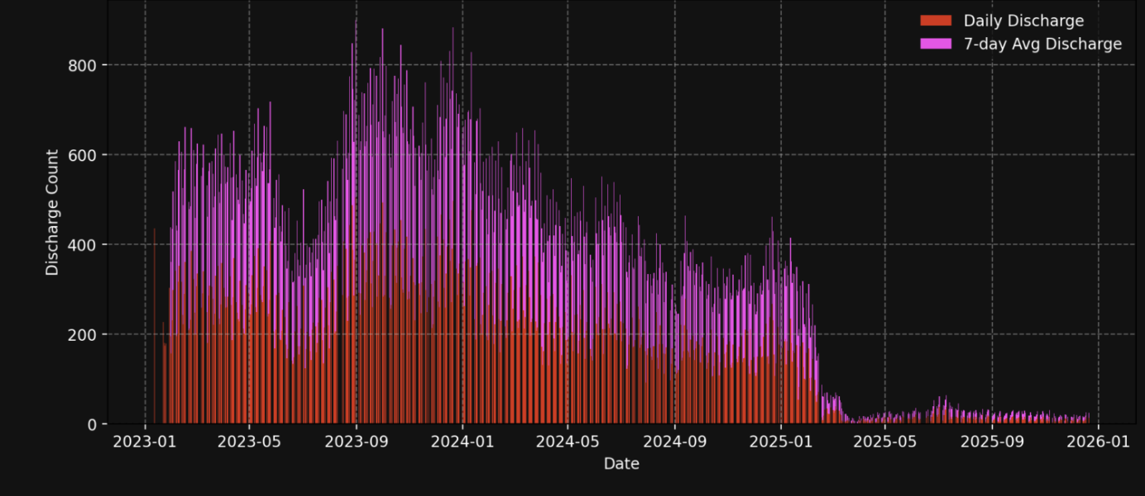

The graphic depicts a time-based trend (from 2023 to 2026) that illustrates changes in data values over time. The vertical bars show variations, with higher bars denoting greater activity or values throughout particular time periods.
It is evident that the activity is comparatively low in the earlier era and begins to rise dramatically around 2025, exhibiting more peaks and unpredictability. This suggests an increase in events, demand, or system activity during that subsequent period.

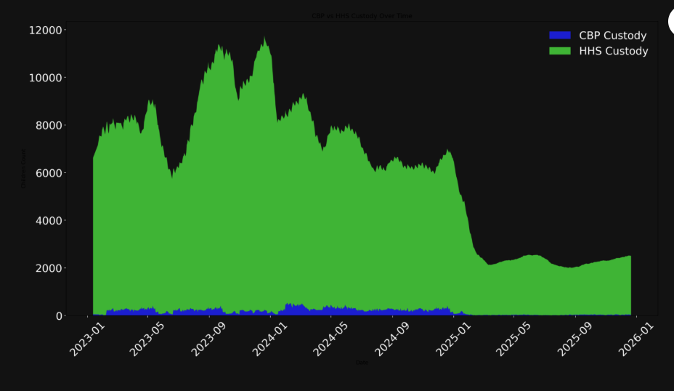

The graph shows the total number of children in custody over time and looks like a stacked area (or full area) chart. The combined volume is displayed in the green-shaded area, which illustrates how the overall custody levels fluctuate over time. A consistent number of children in care is suggested by the trend, which shows that the values initially remain relatively stable at a higher level. However, there is a strong dip in the later period, suggesting a considerable decrease in the number of people in custody, which may be the result of either a decrease in intake or an increase in discharges.

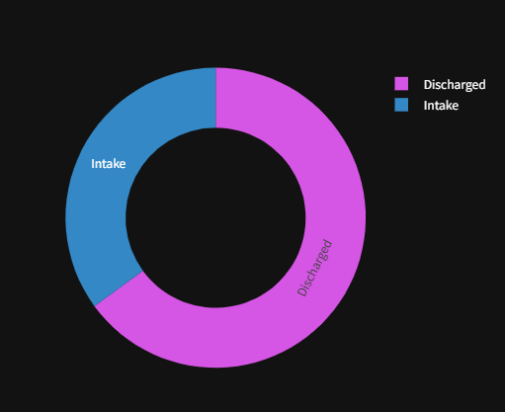

The percentage of Intake vs. Discharged cases in the system is displayed in this donut chart. Discharged cases are represented by the bigger part, intake is represented by the smaller segment. It is clear from the graphic that the system is efficiently processing and discharging cases because discharges are greater than intake. This indicates that the system is operating well, with more kids leaving than entering, which helps to clear the backlog.

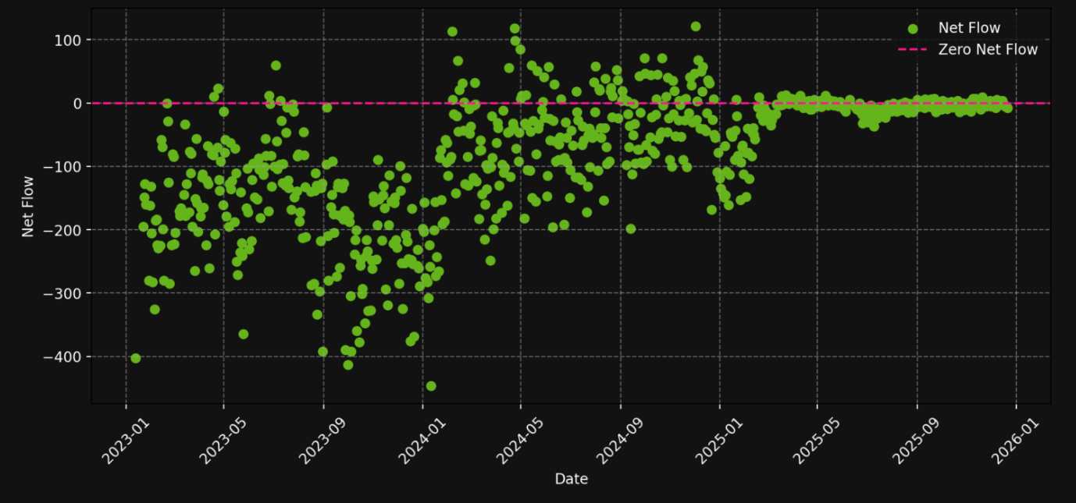
This graph shows Net Flow (Intake − Discharged) as a scatter plot over time. Every point indicates whether more kids are joining or leaving the system at a certain moment.
Discharges exceed intake during those times, as indicated by the majority of the points falling below the zero line (negative values). This implies that the backlog is being successfully reduced and cases are being processed effectively by the system.

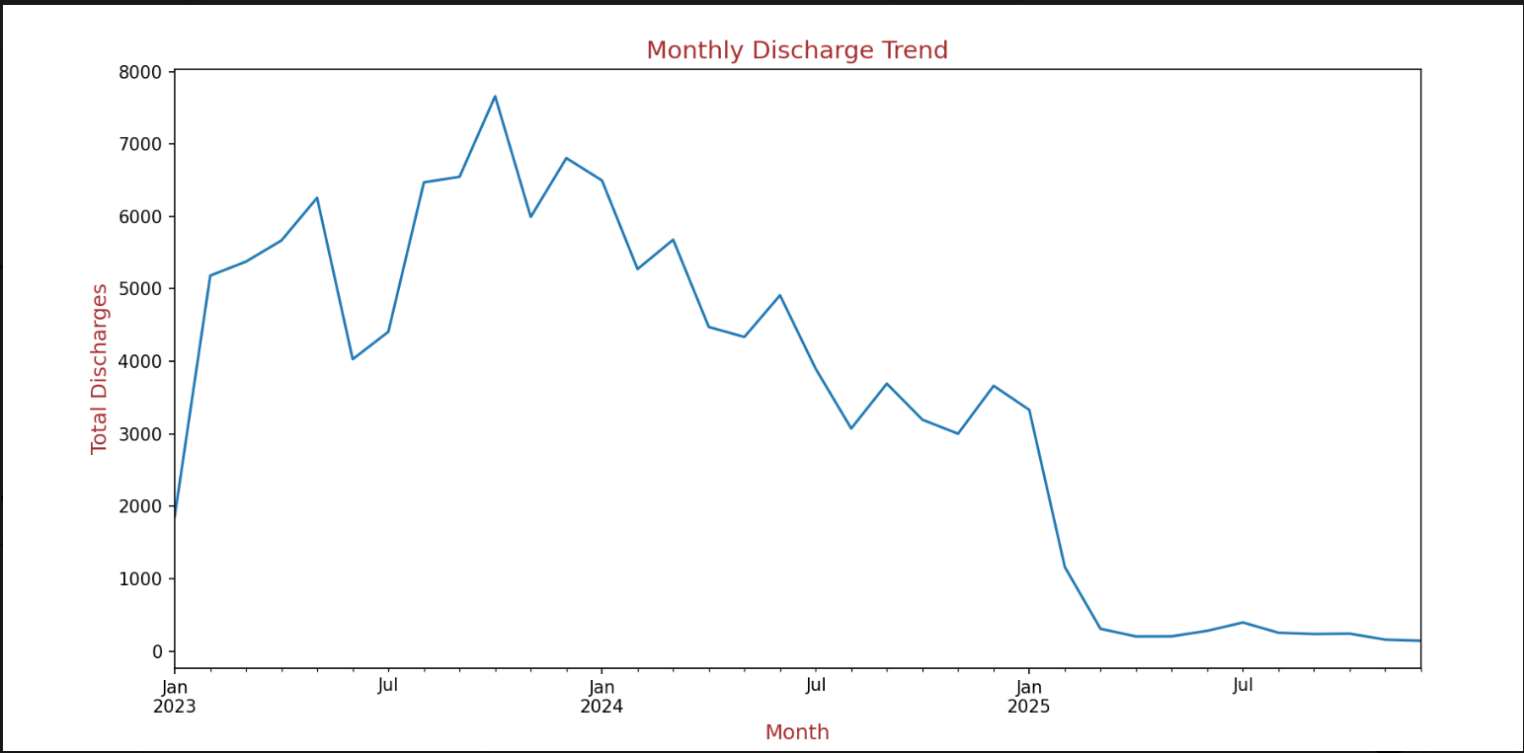
The monthly discharge pattern from 2023 to the beginning of 2025 is depicted in the graphic. Discharges first rise gradually in 2023, peaking in late 2023. Following that, there is a steady decrease in 2024. The trend abruptly declines in 2025, and discharge values become extremely low and largely stationary. All things considered, it shows rapid growth at first, a steady decline, and a notable decline in the latter phase.

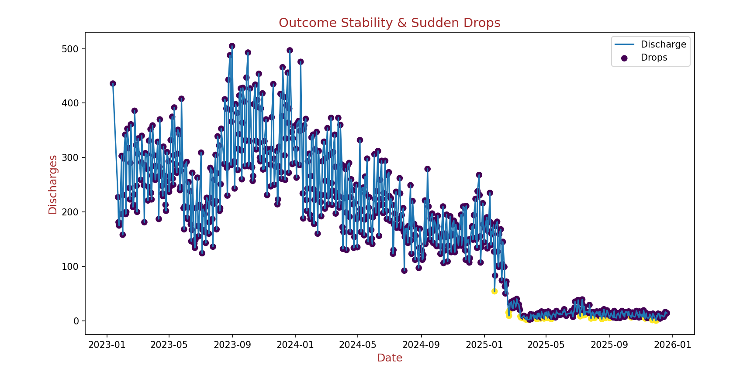
The discharge values vary but are mostly constant between 200 and 400 between 2023 and the beginning of 2024. There is a slow declining trend around the middle to end of 2024, which suggests a drop in discharge levels. The highlighted spots show abrupt declines (outliers) in discharge that are significantly lower than surrounding values. By the end of 2024, these declines become more apparent.
After a significant and steady decline in early 2025, discharge values become extremely low and stable, typically near zero.
5.2 Insights
The care transition pipeline study offers crucial information about the effectiveness and general performance of the system. Strengths and places for improvement are found by analyzing important metrics and visual patterns.
According to the study, transfer efficiency fluctuates over time, suggesting irregularities in the transfer of children from initial care to subsequent stages. Discharge efficacy also varies, indicating that operational or administrative issues may have an impact on the discharge process.
The existence of backlog accumulation, in which intake exceeds discharge during specific times, is an important finding. This imbalance puts more strain on detention facilities and causes system congestion. The pipeline throughput study also shows that the rate of incoming cases does not always correspond with the system's processing capability.
Delays in clearing cases are indicated by periods of positive net flow, which are shown via bottleneck detection. Variations in discharge patterns can point to unstable results, which could compromise the system's consistency.
Overall, the results show that even if the system is working, efficiency, stability, and backlog management need to be improved in order to guarantee a more seamless and successful care handover process.

Chapter 6: Future Work
6.1 Future Work
Although the current project effectively examines the care transition pipeline and offers insightful information through descriptive analytics and visualization, there are a number of ways to improve it further to expand its scope and efficacy.
The integration of machine learning models with predictive analytics is an important area for future research. Models like time-series forecasting and regression approaches can anticipate future intake rates, discharge patterns, and possible backlog scenarios by utilizing existing data. This would enable stakeholders to adopt a more proactive and strategic approach to decision-making instead of a reactive one.
The addition of real-time data processing and live dashboard updates is another significant enhancement. The study is now based on static datasets, but it would be possible to continuously monitor system performance if real-time data sources were integrated.
This would help in identifying issues instantly and taking timely corrective actions.
The addition of geographical and regional analysis can further improve the project. Resource shortfalls, performance variances, and issues unique to a given region could be found by segmenting data according to various locations or operational units. This would facilitate the implementation of policies that are more focused and effective.
To find odd behaviors or abrupt changes in the system, sophisticated analytical methods like anomaly detection, trend forecasting and pattern recognition can be used. This would increase the accuracy of insights and aid in the early identification of important problems.
More interactive elements, like drill-down analysis, user-defined filters, and customizable displays, can enhance the dashboard's design. Improving the user interface and experience will increase the system's accessibility and intuitiveness for various stakeholders.
Another crucial component for upcoming development is scalability. To guarantee improved speed and accessibility, the system can be extended to manage bigger datasets and connected with cloud-based platforms. Furthermore, without the need for manual monitoring, automated reporting and alarm systems can assist in informing stakeholders about dangerous conditions.
In general, future work should concentrate on merging advanced analytics, real-time capabilities, and improved user interaction to make the system more intelligent, adaptive, and scalable. These enhancements would greatly improve the decision-making process and boost the project's usefulness.

Chapter 7: Conclusion
7.1 Conclusion
An interactive dashboard to evaluate the effectiveness and performance of the care transition pipeline for unaccompanied children was successfully created by this project. The study was able to turn unprocessed data into insightful knowledge that promotes a deeper comprehension of system functions by utilizing data analytics and visualization approaches.
Key performance metrics were calculated and examined, including pipeline throughput, backlog rate, outcome stability, transfer efficiency, and discharge efficacy. The results showed variations in discharge patterns, backlog during specific times, and efficiency swings, all of which point to areas that need improvement. Simultaneously, the system showed that it could successfully handle and resolve cases in a number of situations.
The project's effect is found in its capacity to offer a dashboard that offers an interactive, clear view of the entire pipeline. This application allows stakeholders to keep an eye on trends, spot bottlenecks, and make data-driven decisions. All things considered, the initiative helps to enhance decision-making, operational effectiveness, and transparency in the care transition system.

7.2 Reference
• Public dataset related to Unaccompanied Children (UAC) Program (CBP & HHS data), which was made available on the project webpage, served as the primary source of data for analysis in this study.
• To further understand the project specifications, data analysis techniques, and visualization strategies, more references were found using Google.
• Online resources made it easy to learn how to use Python libraries for data processing and dashboard construction, such as Pandas, Matplotlib, Seaborn, and Streamlit.
• Degree textbooks and study materials were also reviewed in order to understand the fundamental concepts of data analysis, data purification, and visualization.
• By using these references, it was feasible to ensure that the project was completed using precise procedures and suitable analytical techniques.

